School District 57
Dzoozt'an Kwun D'ot'en Dzin
(Orange Shirt Day)
RESIDENTIAL SCHOOL RESOURCES
CAUTION: The history of Residential Schools is a very sensitive and traumatizing topic for many people.
If you need support, there is the 24/7 Emergency Crisis Line for those that may need counselling or support
1-800-721-0066 or 24hr Crisis Line 1-866-925-4419
CONTENTS
TRUTH AND RECONCILIATION WEEK 1
RESOURCES 1
PICTURE BOOKS 3
NOVELS 3
ART 3
FILM 8
LANGUAGE 9

TRUTH AND RECONCILIATION WEEK
September 27 - October 1st
For further info and to register:
https://www.eventbrite.ca/e/truth-and-reconciliation-week-tickets-153491752965?aff=ebdssbonlinesearch

RESOURCES
DLC resources for Truth and Reconciliation. Click here for a list of Kindergarten to Grade 12 resources. That page is linked on the DLC homepage (https://prin.ent.sirsidynix.net/client/en_US/dlc) under Featured Links on the right side. It's an orange button that says 'DLC Resources to Support Truth and Reconciliation' and has lesson plans and NFB playlists, as well as photos of our resources linked to the DLC catalogue.
National Centre for Truth and Reconciliation: http://education.nctr.ca/
FNESC Grade 5, 10, and 11/12 http://www.fnesc.ca/irsr/
BCTF Orange Shirt Day Activities https://www.orangeshirtday.org/.../bctf...
BCTF Orange Shirt Day Activities: https://bctf.ca/uploadedFiles/Public/AboriginalEducation/OrangeShirtDayActivities.pdf
SD73 Response Guide to the
Deputy Minister’s Bulletins on Residential Schools Teaching Supports and Mental Health Resources
BCTF Gladys We Never Knew Online Interactive Resource
Legacy Schools Resources - The Gord Downie & Chanie Wenjack Fund (downiewenjack.ca)
RESOURCES / SUPPLIES (orangeshirtday.org) This website provides teacher resources, reading materials, videos, history of Orange Shirt Day activities
Some resources Rob Lewis created for Social Studies 10 https://www.lewisland007.com/residential-schools.html
Thalit Sqwelqwel Stories of Truth (greatspirithand.com) This website has K-12 age appropriate teaching resources / videos / 360 virtual tour of St. Mary’s residential school in Mission BC / Drone flyovers, etc / Elders and Survivors corner. This was created by Elders, Survivors and consultation with master teachers to ensure age suitability. Teachers have resources on Pre-Contact / Residential Schools / Reconciliation / Worldviews)
Witness Blanket - A National Monument to recognize the atrocities of Indian Residential Schools. This is an excellent website with documentaries, resources, etc
Indian Residential Schools and Reconciliation Resources - First Nations Education Steering Committee FNESC Grade 5, 10, 11/12 eBooks with guided lesson plans, suggested topics, information re: protocols, supports, etc
Suggested resources | Indian Residential School History and Dialogue Centre (ubc.ca) eBook intended to be an interactive resource leading educators to resources including videos, documents, articles, activities and more
Project of Heart
Witness Blanket https://witnessblanket.ca
The Secret Path: Website
- About
- Music
- Book
- Film
- Shows
- Donate
- Credits
- ORDER
A Knock on the Door This website has resources including eBooks, 6 step learning module that have been used by educators in 1000’s of classrooms from coast to coast. A Knock on the Door, published in collaboration with the National Centre for Truth and Reconciliation (NCTR), gathers material from the TRC reports to present the essential history and legacy of residential schools and inform the journey to reconciliation that Canadians are now embarked upon. An afterword introduces the holdings and opportunities of the NCTR, home to the archive of recordings and documents collected by the TRC.
Order Here https://uofmpress.ca/books/detail/a-knock-on-the-door
Audiobook narrated by Michelle St. John. Accessible audio resources for this title can be found here.
Surrey Schools Aboriginal Education https://docs.google.com/.../102fL5BZ6PXvyoKwZy.../edit
ARE YOU LOOKING TO LEARN MORE ABOUT RESIDENTIAL SCHOOLS YOURSELF? Check out this clickable .pdf that is full of resources for your self-directed pro-d: https://www.facebook.com/.../permalink/369454867823818/ Thank you to Angela Marcakis, a teacher from Surrey, for the following list of resources for your own education, and/or to teach your students about residential schools and their lasting impact

PICTURE BOOKS
Phyllis’s Orange Shirt by Phyllis Webstad
The Orange Shirt Story by Phyllis Webstad
Secret Path by Gord Downie
When I Was Eight by Christy Jordan-Fenton
I Am Not A Number by Jenny Kay Dupuis
Stolen Words by Melanie Florence
Shi-shi-etko by Nicola I. Campbell
Shin-chi’s Canoe by Nicola I. Campbell
When We Were Alone by David Alexander Robertson
Kookum’s Red Shoes by Peter Eyvindson

NOVELS
Red Wolf by Jennifer Dance
My Name Is Seepeetza by Shirley Sterling
Dear Canada: These Are My Words: Residential School Diary by Violet Pesheens
No Time To Say Goodbye: Children’s Stories of Kuper Island Residential School by Sylvia Olsen
Goodbye Buffalo Bay by Larry Loyie
As Long As The River Flows by Larry Loyie
Fatty Legs: A True Story by Christy Jordan-Fenton
Stranger At Home: A True Story by Christy Jordan-Fenton
Sugar Falls: A Residential School Story by David Alexander Robertson
They Called Me Number One: Secrets and Survival at an Indian Residential School by Chief Bev Sellars
Indian Horse by Richard Wagamese

ART
Witness Blanket https://witnessblanket.ca
Shame and Prejudice: A Story of Resilience By Kent Monkman https://moa.ubc.ca/exhibition/shame-and-prejudice/
MORE COLOURING PAGES CAN BE FOUND HERE:
https://www.urbaniskwew.com/coloring-pages

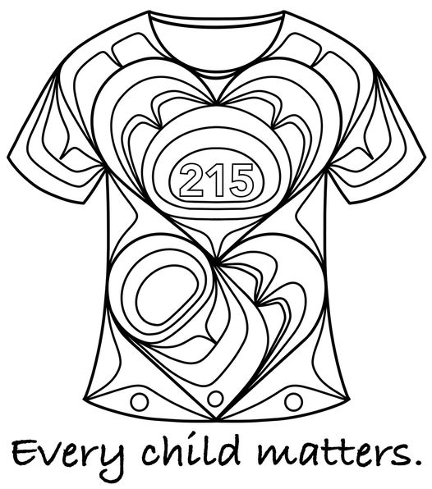
"I had a teacher ask if I had a design she can use to teach her students about Residential school so I thought I would draw up a colouring page. Free for anyone to use for personal use or educational use. Please do not use for profit. #EveryChildMatters - Yasakw Yakgujanaas Designs ( Shelly Samuels )

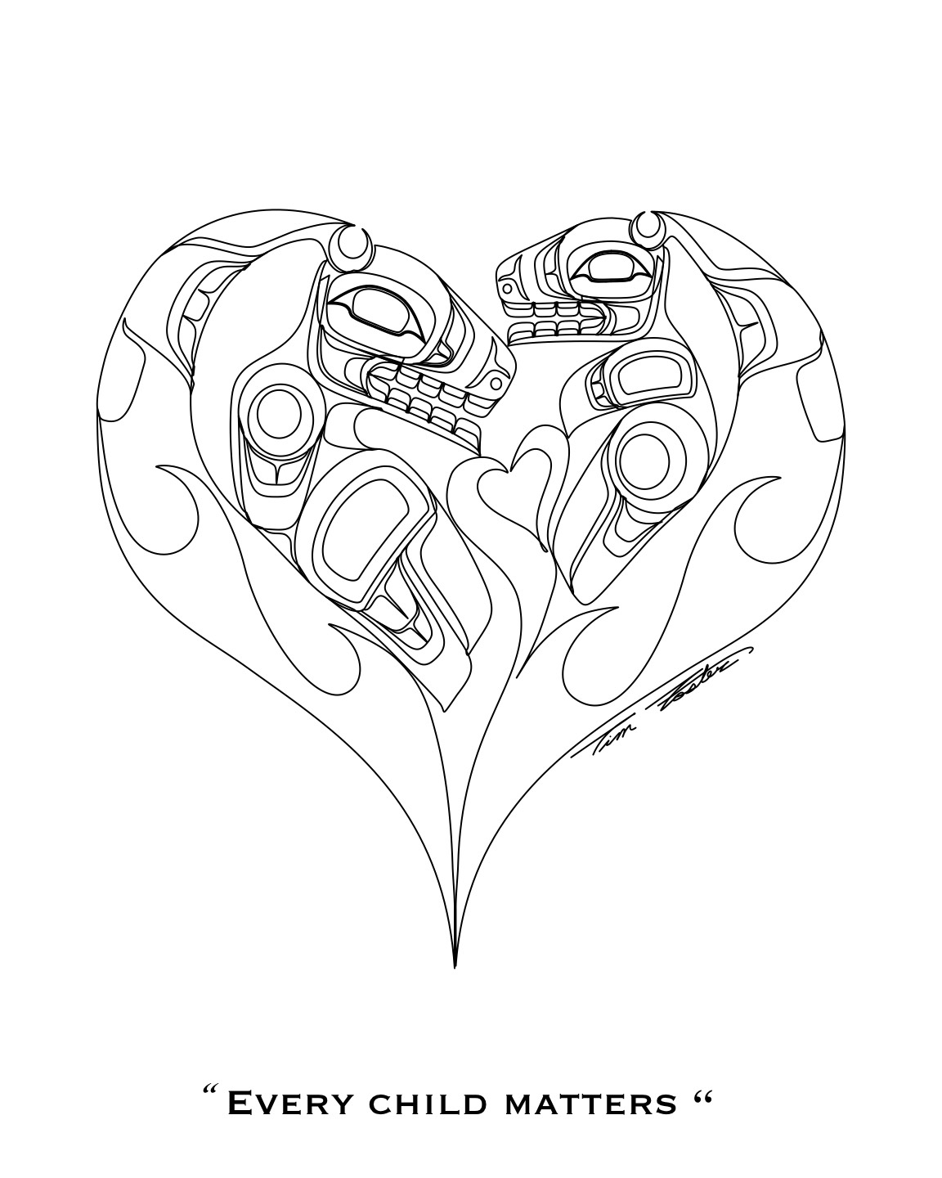
Colouring sheet by Tim Foster, Gitxsan

Backgrounds by Jennifer Pighin
Translation by Edith Frederick
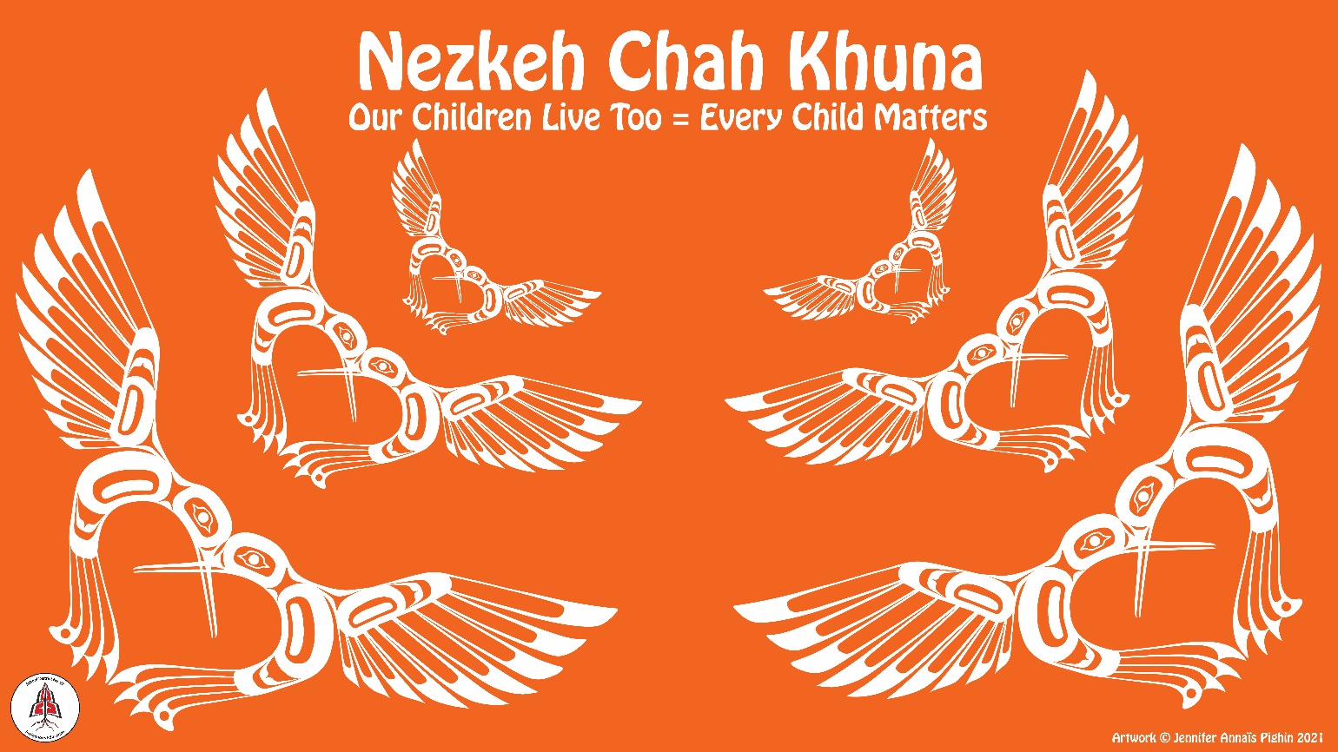
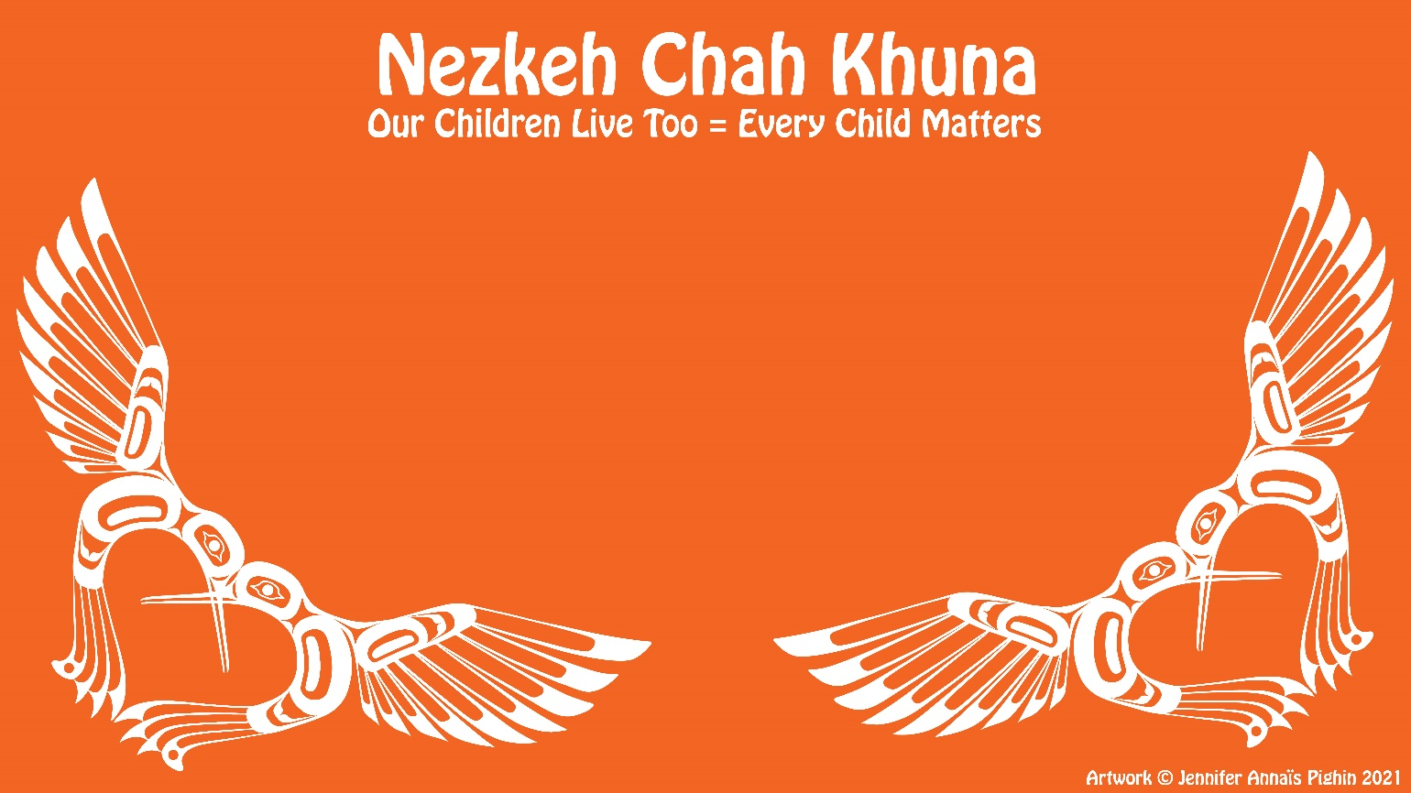
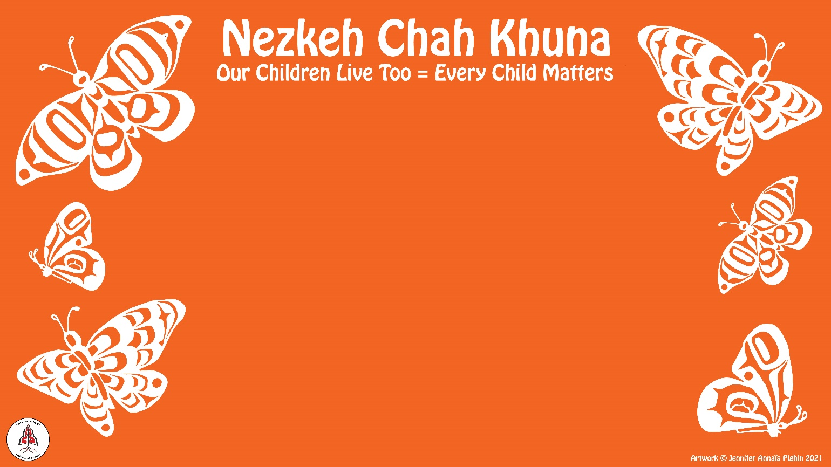

FILM
Canadian History and the Indian Residential School System - SD 27 Gr 5/10 20min. https://www.youtube.com/watch?v=6-28Z93hCOI
For a limited time only, this powerful documentary is great learning for anyone and can be shared with classes. Be sure to lead up to the film by pre-teaching some cultural sensitivity and the history of residential schools. https://vimeo.com/254051287
Reccomended from IRSHDC
Náskan Ūxwal (I’m Going Home) Documentary 2017 - YouTube This documentary is an excellent teaching tool re: Kamloops Indian Residential School
St Mary's Documentary - YouTube Grades 11/12, 35- minute documentary by Bear Image Productions, on St. Mary’s Residential school
St. Joseph's Residential School Stories - YouTube Brief Documentary on St. Joseph’s Residential School. Stories from survivors including Phyllis Webstad of “Orange Shirt Day” origin
CBC Curio
CBC Curio - Beyond 94 - https://newsinteractives.cbc.ca/longform-single/beyond-94?&cta=1
CBC Art - Road to Reconciliation - https://curio.ca/en/video/cbc-arts-road-to-reconciliation-panel-discussion-12161/
CBC The National - Ending the Cycle of Abuse - https://curio.ca/en/video/ending-the-cycle-of-abuse-6408/
CBC Interview with Justice Murray Sinclair - https://curio.ca/en/video/justice-murray-sinclair-interview-6933/
CBC Is the Canadian Government Delivering on TRC? - https://curio.ca/en/video/is-the-canadian-government-delivering-on-truth-and-reconciliation-17206/
CBC News Residential School Shame - The TRC Report - https://curio.ca/en/video/residential-school-shame-the-trc-report-6990/
CBC News - Sir John A Macondald - A Legacy of Controversy - https://curio.ca/en/video/sir-john-a-macdonald-a-legacy-of-controversy-19843/
CBC News - Justice Murray Sinclair on Nutrition Experiments on Aboriginal Children - https://curio.ca/en/video/justice-murray-sinclair-nutrition-experiments-on-aboriginal-children-3549/
CBC The National - Stolen Children Truth and Reconciliation https://curio.ca/en/video/stolen-children-truth-and-reconciliation-1055/
CBC - Treaties, Reconciliation and Indigenous History in Canada - https://curio.ca/en/video/treaties-reconciliation-and-indigenous-history-in-canada-15289/
CBC The Current - Why don't residential school survivors just get over it?: Murray Sinclair - https://curio.ca/en/video/why-dont-residential-school-survivors-just-get-over-it-murray-sinclair-15301/
NFB
Minqon Minqon : Wosqotomn Elsonwagon (Shirley Bear: Reclaiming the Balance of Power) - https://www.nfb.ca/film/minqon-minqon-wosqotomn-elsonwagon-shirley-bear/?ctlgsrc=mr
Can-Core
Residential Schools Playlist - https://www.can-core.ca/studentlist/1549 (Access code: CANCOREu960FaCX)
Beyond 94: Truth and Reconciliation in Canada
Beyond 94: Truth and Reconciliation in Canada newsinteractives.cbc.ca

LANGUAGE
Dakelh
Hello Friends/Relatives
Hadih st’ekene Hello my friends/relatives
Hadih t’ekooke Hello friends/relatives
Hadih t’eke Hello friend/relative

Orange Shirt Day - Dzoozt’an Kwun D’ot’en Dzen

Every Child Matters – Nezkeh Chah Khuna

Healing Words in Lheidli Dialect
nasjeh I am healing, getting better
nainjeh you (1) are healing
najeh S/he/they/it is/are healing
naidujeh we (2) are healing
nats'ujeh we (3+) are healing
nahjeh you (2+) are healing
nahujeh they are healing
natejeh s/he/they/it will heal
naje s/he/they/it healed

Nk’essui’ I Love You (1)
Nahkw’essui I Love You (2+)
Nk’ets’intsi’ We (3+) Love You (1)
Nk’ehintsui They love you (1)
Nahkw’entsui S/he/they/it love/s you (2+)

Wednesdays: Learn Dakelh with Jennifer Pighin @ 2:30 & 3:30
Thursday: Dakelh Language Lessons on Facebook @ lunch

